To the University Community,
Voluntary Demographic Self-Identification Re-survey
(Race/Ethnicity, Veteran Status, and Disability)

The University of Connecticut is an affirmative action/equal employment opportunity employer, committed to employing and advancing all qualified individuals. As a federal contractor and state agency, the University of Connecticut is required to report demographic data about the workforce including race/ethnicity, veteran, and disability data. As part of its compliance obligation, the University is required to periodically provide members of the workforce an opportunity to update their information.

In order to comply with these laws, the University invites employees to voluntarily self-identify their ethnicity, veteran, and disability data via the Core-CT Self-Service System. Submission of this demographic information is voluntary. The information obtained will be kept confidential and may only be used in accordance with the provisions of applicable laws, executive orders, and regulations, including those that require the information to be summarized and reported to the federal government.
Employees will use the Core-CT Self-Service System (ess.uconn.edu) to voluntarily disclose demographics in the Personal Information Section, using the bottom three menu items shown:
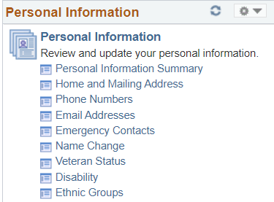
Please also note that these self-service options for voluntary demographic identification are accessible throughout the entire year.
If you desire detailed instructions for disclosing the data via the above options, please utilize the Personal Information Job Aid. If you have further system issues entering the data, please contact Human Resources Information Systems (HRIS) via email.
If you have questions regarding the University’s collection of race/ethnicity, veteran status, and disability data, please reference our Frequently Asked Questions. If you have further questions, please contact the Office of Institutional Equity via email.
Thank you for your participation.
Office of Institutional Equity & Office of Human Resources

